Jacques Louw

[Email address]

Abstract

[Draw your reader in with an engaging abstract. It is typically a short summary of the document.   
When you’re ready to add your content, just click here and start typing.]

IP PAT

[Document subtitle]

Contents

Scenario 2

User Requirements 3

Navigation/Description of flow diagram 4

GUI design 5

frmWelcome 5

frmWelcome data structures 5

frmWelcome IPO table 5

# Scenario

Video provides a powerful way to help you prove your point. When you click Online Video, you can paste in the embed code for the video you want to add. You can also type a keyword to search online for the video that best fits your document.

To make your document look professionally produced, Word provides header, footer, cover page, and text box designs that complement each other. For example, you can add a matching cover page, header, and sidebar. Click Insert and then choose the elements you want from the different galleries.

Themes and styles also help keep your document coordinated. When you click Design and choose a new Theme, the pictures, charts, and SmartArt graphics change to match your new theme. When you apply styles, your headings change to match the new theme.

Save time in Word with new buttons that show up where you need them. To change the way a picture fits in your document, click it and a button for layout options appears next to it. When you work on a table, click where you want to add a row or a column, and then click the plus sign.

Reading is easier, too, in the new Reading view. You can collapse parts of the document and focus on the text you want. If you need to stop reading before you reach the end, Word remembers where you left off - even on another device.

# User Requirements

In this program I will have 2 users. One will be a banker that needs to encrypt the banks data. The second user will be a banking client that would like to see their account details.

|  |  |  |  |
| --- | --- | --- | --- |
| As a … | I would like to … | So that I can … | **Acceptance test** |
| Banker | Encrypt the banks data | Send the data over the internet without giving away private information. | **Encrypt data** –  Data not recognisable  **Sent data over internet** – When the client receives the data |
| Banker | Decrypt the data | Work with the data and create reports | **Decrypt data** –  Data is recognisable  **Work with data** –  Do calculations / work with data  **Create reports** –  See summaries |
| Client |  |  |  |
|  |  |  |  |

# Navigation/Description of flow diagram

# GUI design

## frmWelcome

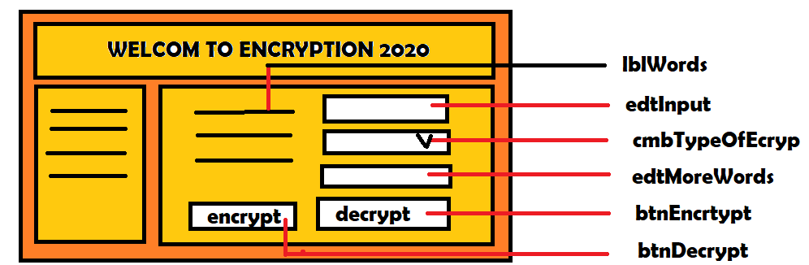

## frmWelcome data structures

variables that I will use

**Strings**

sInput – Used to get the input from the user

sOutput – used to display the output

**Integers**

…

## frmWelcome IPO table

|  |  |  |
| --- | --- | --- |
| Input | Processing | Output |
| Keyboard input   * edtInput   The input needs to be in the following format:  Yyyy/mm/dd    Validation:  Presence check   * edtMoreWords   Format : R ##.## | * presence check |  |
| Component inputs   * Button - Encrypt * cmbType.. | I will take the shift amount, build up a new alphabet and display the char at the correct place. |  |